Goal, Question, Metrics Practical
Read the GQM slides
Use the tables below to add your questions and metrics. Insert or delete rows as you need. Copy and paste the table if you have more questions.

Goal 1- Maintain a high level of Software Quality Testing
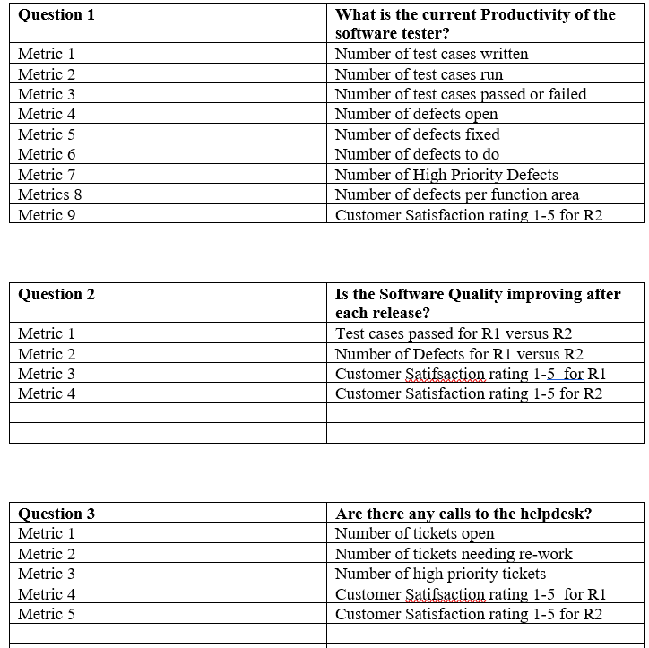

Goal 2 - Improve the timeliness of change request processing.

Q1 What is the current change request processing speed?
Q2 Is the (documented) change request process actually performed?
Q3 What is the deviation of the actual change request processing time from the estimated one?
Q4 Is the performance of the process improving?
Q5 Is the current performance satisfactory from the viewpoint of the project manager?
Q6 Is the performance visibly improving?

